Register your Business Details below for Sparklewhite Teeth NZ
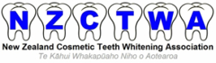
First Name |  | Last Name
Business Name |  | Business Address
Facebook |  | Email
Landline |  | Mobile

For marketing purposes please tell us more about your business & how you heard about Sparklewhite Teeth NZ Ltd:
_____________________________________________________________________
I/We understand and agree that the information received from Sparklewhite Teeth NZ is highly confidential and is being made available to me/us due to my/our interest in the Sparklewhite Teeth Package and will be held in the strictest confidence.

I/We shall not divulge nor use any financial information, data, trademarks, trade secrets, methods, concepts, formulae, processes, diagrams, or marketing and advertising materials provided to me unless already in the public domain.

All information provided on this form will be held confidentially by Sparklewhite Teeth NZ and will only be used for our marketing purposes. Sparklewhite Teeth NZ will not distribute any information provided to any third parties.

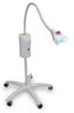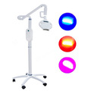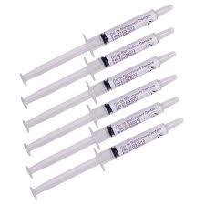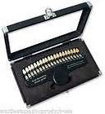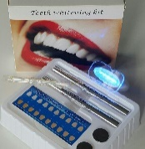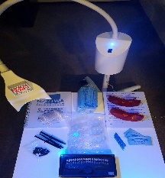

I agree to the information provided by Sparklewhite Teeth NZ and it will be held in confidence;

Signature: ………………………………………………………………….. Date: __ / __ / __

